March 2022

**BAYNOTES**

Empowering Women since 1881 – Through Advocacy, Education, Philanthropy and Research  
Branch Website: greenbayarea-wi.aauw.net

**MARCH BRANCH MEETING  
 Monday, March 21th  
 6:30 pm via Zoom   
 Join Zoom Meeting** <https://us02web.zoom.us/j/84956274035?pwd=NEcyeXhVbmlsNmNESlhBOVpwdTlEdz09>

**Moving Towards Zero Waste  
Dean Hoegger, President & Executive Director   
Clean Water Action Council of Northeast Wisconsin**

Zero waste is a philosophy and design principle for the 21st century. It makes a shift from traditional waste management, where the focus was keeping recyclables out of the trash, to material management, where trash is what remains after we reduce, reuse, recycle, and compost. It aims to eliminate, rather than manage waste. Zero waste maximizes recycling, minimizes waste, reduces consumption and promotes the manufacturing of products that are made to be reused, repaired, or recycled back into nature or the marketplace. The use of landfills is greatly reduced through zero waste.

The Clean Water Action Council of Northeast Wisconsin Non-Profit Corporation is organized to promote a safe, healthy, and sustainable environment in northeast Wisconsin, to educate and inform members and the public on environmental issues, and to take action on behalf of members and the public to protect the environment and human health.

-------------------------------------------------------------------

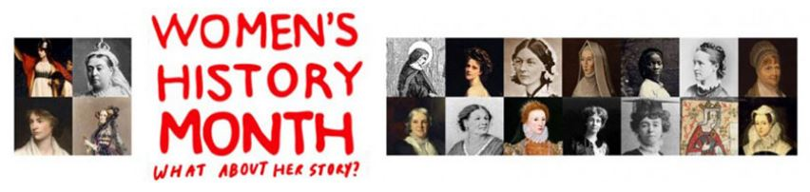

**INTEREST/STUDY GROUPS**

**ART STUDY GROUP  
Carolyn Reedy & Mary Woodbridge**

**Thursday, March 10th 10:00 am-12:00**  
**Cheesecake Heaven Lounge Oneida St.**  
Natvie American speaker is scheduled.  
Alternate presentation will be “Art Heists.” # 1 DVD, a series on PBS several years ago.

Regular and decaf coffee will be served with a platter of Danish. Everyone is invited to attend.

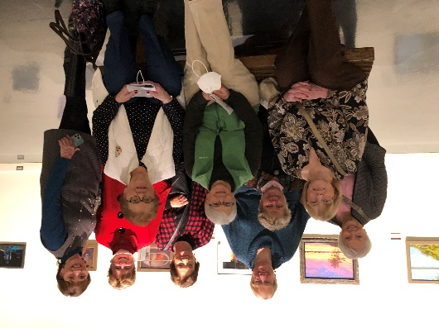This past month the Art Group met at the Neville Museum to view the 107th Green Bay Art Colony Exhibit.

**¡ADELANTE! BOOK GROUP**  
Mary Barker **Wednesday, March 16 5:30 pm**  
Green Bay Distillery – Mike McCarthy Way   
Leader: Terri Gulyas

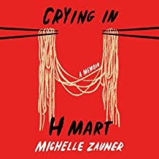**Book: Crying in H Mart by Michelle Zauner**Written with humor and heart, Zauner tells of growing up one of the few Asian American kids at her school in Eugene, Oregon; of struggling with her mother’s particular high expectations of her; a painful adolescence and treasured months spent in her grandmother’s tiny apartment in Seoul where she and her mother would bond over heaping plates of food.

**AFTERNOON BOOK GROUP  
Wendy Schroeder**

**Monday, March 28th 3:00pm**Lion’s Mouth Bookstore

**Book: Invisible Life of Addie LaRue   
by V E. Schwab**

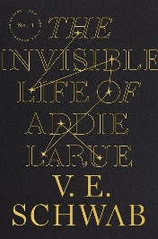France, 1714: in a moment of desperation, a young woman makes a Faustian bargain to live forever—and is cursed to be forgotten by everyone she meets.  
Thus begins the extraordinary life of Addie LaRue, and a dazzling adventure that will play out across centuries and continents, across history and art, as a young woman learns how far she will go to leave her mark on the world.  
But everything changes when, after nearly 300 years, Addie stumbles across a young man in a hidden bookstore and he remembers her name.

**AAUW Board Meeting**Thursday, March 24. 6:30 pm  
Via Zoom

**PRESIDENT’S MESSAGE**Lindsay Mather

This is an open call for members to consider a position on our leadership team.  Each year we have openings for offices that need to be filled.  Please think about how you can contribute to our branch.  Any position can be done with co-partners and makes the work easier.

I will be contacting our current officers/leaders to see if they will be returning next year, and in next month's Bay Notes I'll provide an update about the remaining open positions you can consider.   Thanks to all who have contributed their time this year to make our branch successful.

**WATER STUDY GROUP  
Carol Pearson**

**UW study finds Wisconsin rivers contributing to ‘forever chemical’ concentrations in bay of Green Bay, Lake Michigan**

**By Laura Schulte, MJS, February 18**

Tributaries feeding into the bay of Green Bay play a large role in moving "forever chemicals" into Lake Michigan, according to a study by UW-SMadison researchers, even though the chemical levels in the rivers are below recommended state standards.

Christy Remucal, an associate professor with the UW Department of Civil and Environmental Engineering, and postdoctoral investigator Sarah Balgooyen looked at the water and sediments within 41 of the tributaries that feed water into the bay, and the impact water from tributaries broadly could be having on the Great Lakes. The study was funded by the Wisconsin Sea Grant.

"I think one of the big take home messages is that of the rivers we studied, we found that three large rivers — the Fox, the Menominee and the Peshtigo — contribute over two-thirds of the load of PFAS to the bay," she said. "That may seem kind of obvious, but it's important to note that the concentrations of these three rivers are well below levels of concern."

Read more at: <https://www.jsonline.com/story/news/local/wisconsin/2022/02/18/uw-study-finds-rivers-emptying-forever-chemicals-in-lake-michigan/6788183001/>

---------------------------------------

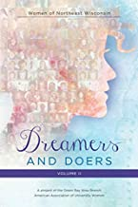**Celebrate Women’s History Month** with a gift to someone of our Branch’s Women of Northeast Wisconsin Dreamers and Doers vol. II.

Go to our website greenbayarea-wi.aauw.net to order.

Discover the women, past and present, who have shaped and influenced the framework and fabric or our area.

**SCHOLARSHIPS**  
Sara Ramaker

March is when AAUW Green Bay Branch will be making the payments for our annual scholarships at UWGB Green Bay, NWTC and Bellin College. Our new procedure allows the schools to pick the candidates based on the criteria we have submitted. The scholarships will total $1000 each, with $550 coming from our Green Bay Community Foundation funds and $450 from our branch’s scholarship fund raising.

**PUBLIC POLICY**  
Sara Ramaker

**Update on Wisconsin’s Redistricting**

This email from Penny Bernard Schaber best describes where we are on ending gerrymandering in Wisconsin: “Thank you for your ongoing interest in supporting Fair Voting Maps and ending political Gerrymandering of voting districts.

 If we look back eight to ten years ago, most people knew very little about redistricting or the impact of Gerrymandering on legislative decisions and their lives. Significant progress has been made in the State but unfortunately the current legislature and State Supreme Court have rejected the overwhelming public support for Fair Maps and putting an end to Gerrymandering.

 As it stands, the Supreme Court of Wisconsin will soon make a decision on Congressional, Assembly and Senate voting districts for the next ten years. The Supreme Court decided in November to adopt the “least change” approach to redistricting; in essence locking in the current voting maps. This is an unfortunate rebuke of all the work done by thousands of people in Wisconsin and an attempt by the Court to make a new “law” on setting voting districts.

We have had many discussions locally and statewide on what should be done. At this time, we are waiting for the Wisconsin Supreme Court to make a decision and then will let you know the next steps. If the Federal District Courts should weigh in on any Voting Rights Act violations we do not expect that they will make any major district boundary changes.

 We MUST continue to do our work to protect democracy in Wisconsin. Much is at stake for the future of our State and ALL of the people that live here. Here are several things you can do.

*    Participate in a Video making plan called “I’M Mad About Maps”. See attachment for details and how-to information or check out this link: <https://www.fairmapswi.com/mad>.

*Throughout 2022, support only candidates that sign a pledge to vote for Nonpartisan Redistricting legislation and continue to support a nonpartisan process for redistricting.

* Work diligently to support candidates in other offices that can provide a check and balance on the public policies of the current legislature. Learn about local judicial candidates and elections.

* Keep up to date on the Wisconsin Supreme Court election in 2023.

* Support a new bi-partisan effort to initiate Final 5 Voting: SB250: <https://docs.legis.wisconsin.gov/2021/proposals/sb250>

*Stand up for election integrity and support your local clerk and volunteer to become a poll worker. Learn more at: <https://allvotingislocal.org/state/wisconsin/>

* Purchase and read the book: 12 Ways to Save Democracy in Wisconsin written by Matthew Rothschild. Then develop your own action plan in conjunction with others.

 We MUST not give up. Do whatever you can with your friends, neighbors and family to support Fair Maps. Provide information for them and get them involved in THEIR democracy.

 Here is a Mexican proverb that pertains to this time in the history of Wisconsin: ‘They tried to bury us. They didn’t know we were seeds’.”

**AAUW WI Convention Update**

**Reminder to mark your calendar and plan to attend the** **and plan to attend the AAUW-WI state convention (via Zoom), Friday evening and Saturday, April 22 and 23. Registration information should be coming out soon.**

**HELP NEEDED**: As a reminder I am hoping for more contributions from each of you for the branch basket. I was told that the most popular baskets had items in them that encouraged people to visit the area. If you have a local place that you frequent often and want to encourage others to do the same, ask them for a gift certificate for the basket. Most business owners are happy to do this for a good cause, especially if it can help to bring in new customers. All proceeds from the auction are going to AAUW’s General Needs Fund. I will be happy to pick up any items or you can drop them off at my home. I will need the items by March 25. Thank you for your help!

---------------------

**Meet 2021-2022 AAUW Fellowship/Grant recipient: Alba Mendiola (Dillion**

AAUW has been a leading source of funding for graduate women, providing more than $115  
million in fellowships and grants to more than 13,000 women and organizations in the US and around the world. Its programs support aspiring scholars, teachers and activists in local communities, women at critical stages of their careers, and those pursuing professions where women are underrepresented. AAUW is providing nearly $5million in 2021–22 in support of 250 scholars.

These are the statistics. They sound impressive, but not as impressive as one of the recipients, Alba Mendiola Dillion, 2021-2022 American Association of University Women (AAUW) Awardee. I participated in the AAUW Jane Addams program featuring Ms. Mendiola who spoke of her past experiences and goals. She was very grateful for the AAUW grant she received. Clearly this additional funding meant that she could pursue her teaching certificate. Alba Mendiola was born in a small city in Mexico. Her parents could afford to send her to college and she graduated with a degree in media studies. After college she spent 18 years as investigative reporter for Azteca in Mexico and later at Telemundo in Chicago, receiving 7 Chicago regional Emmy® Awards as an investigative reporter with Telemundo Chicago, including best reporter and outstanding single investigative story. She left reporting and now has more than five years of experience as a bilingual educator primarily in underserved neighborhoods. She loves where she is teaching, but feels the teaching certificate is necessary for her career to grow. She plans to finish the degree requirements by the end of 2022. Her enthusiasm and motivation must create a wonderful, inspiring teacher. To say I was impressed is an understatement. I attend the program, because I was curious about AAUW grants. I did not realize the boost it would give me. To know we are a part of this national organization that is doing such wonderful things makes all the work worthwhile. Just wanted to pass a bit of the boost on to all of you.

Alba is married to Jason Dillon and has two daughters. She used her married name when she first moved to Chicago, but her television name was Mendiola and she is using it, too. Alba has also participated as a speaker, panelist, moderator, and masters of ceremonies in several conferences organized by non-for-profits, universities, and schools in the US and Mexico.

Finally, I asked Alba, having recently applied for the grant, what changes she would make to the AAUW process. She said she saw no need for change. Good to know.

# **Join International Women's Day Celebration on March 8 (online)**

The University of Wisconsin-LaCrosse International Women’s Day Committee invites members of the La Crosse community and beyond to a virtual celebration of International Women’s Day on Tuesday, March 8 from 7-8 pm

 The celebration will consist of a panel discussion with a special emphasis on how women are celebrated in their country as well as their experiences in both their country of origin and the U.S. Panelists will include Labelle Sandra B. Mpemwangi representing Congo, Oryssia Felts representing Ukraine, and Thanh Bui-Duquette representing Vietnam. This year’s celebration will take place via Zoom and is free to the public. Prior registration is suggested; please visit <https://wisconsin-edu.zoom.us/webinar/register/WN_JENM-YIBSvCKZV_Iz1f2oA> to register for the event. After the panelists speak, time will be set aside for questions from the audience.

International Women’s Day is celebrated in countries around the world each year on March 8. The theme for the 2022 International Women's Day is #BreakTheBias: Imagine a gender equal world. A world free of bias, stereotypes and discrimination. A world that's diverse, equitable, and inclusive. A world where difference is valued and celebrated. Together we can forge women's equality. Collectively we can all #BreakTheBias.

Sponsoring organizations include the American Association of University Women, the League of Women Voters of La Crosse, the University of Wisconsin-La Crosse, Franciscan Sisters of Perpetual Adoration, North Woods International School, the Women’s Fund of Greater La Crosse, Viterbo University, and the International Women’s Group.

For more information, please contact:  
Erica Koonmen, AAUW  
aauwlacrosse@hotmail.com