/v

December 2021

**BAYNOTES**

Empowering Women since 1881 – Through Advocacy, Education, Philanthropy and Research  
Branch Website: greenbayarea-wi.aauw.net

**AAWW Branch Holiday Lunch**

Entertainment – Four Hits and a Miss White Elephant Gift Exchange

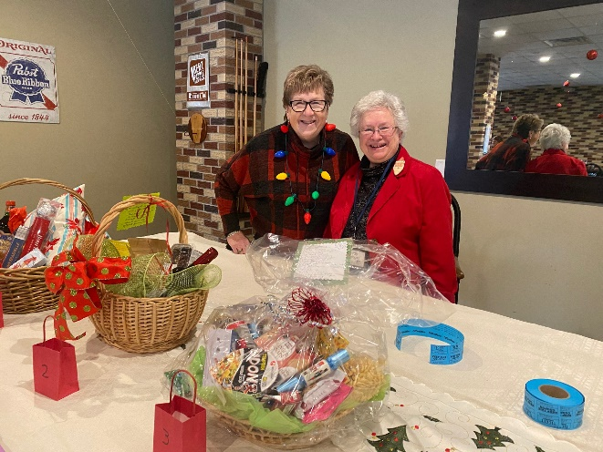

Our Greatest Needs Fund Basket Raffle raised $230. A special thank you to Mary Schmidt, Carolyn Reedy, Jill Lauritsen and Nancy Anderson for making up the beautiful baskets. Thanks to the local band Four Hits and a Miss for the holiday tunes and merriment. And for planning a lovely afternoon thanks to Mary Schmidt, Linda Birder and Nancy Anderson

**--------------------------------------------------------------------------------------------------------**

**Note date change for January Movie Night - now Tuesday, January 25th with a snow day of Monday January 31st. We will be at Sandy Melroy’s home 1931 Rainbow Ave. De Pere. 5:30 pm dinner 6:15 pm Movie: Nomadland. Dinner will be packaged meals from Festival. More details in January newsletterINTEREST/STUDY GROUPS**

**¡ADELANTE! BOOK GROUP**  
Mary Barker

Date:  Wednesday, December 15  
Time:    6:30 p.m.

Place:  Green Bay Distillery   
Leader: Mary Barker

Book: **On Looking: A Walker’s Guide to the Art of Observation** by Alexandra Horowitz.

Structured around a series of eleven walks the author takes, mostly in her Manhattan neighborhood, On Looking features experts on a diverse range of subjects, including an urban sociologist, the well-know artist Maira Kalman, a geologist, a physician and a sound designer.

**ART STUDY GROUP**Carolyn Reedy & Mary Woodbridge

Thursday, December 16..  10:00 am  
**National Railroad Museum in Green Bay to view the “Festival of Trees” exhibit.**   
10:00. (Please let Carolyn or Mary Woodbridge know if you need a ride.)T  
There are over 40 trees decorated by local businesses and non-profit organizations.

The cost is $6 and you can pay for your ticket online at nationalrrmuseum.org or at the museum.

After our visit (11:30 ish) we will meet at Carolyn Reedy’s home for lunch and socializing. If you are unable to make it to the museum please feel free to come for lunch! (516 E. Eagle Terrace. Green Bay 54313) RSVP at 920-496-9169 or 920-366-2942

**JANUARY BOARD MEETING**   
Thursday, January 13 at 6:30 pm via zoom  
All members are welcome to participate in board meetings at any time.

**Other Art opportunities for December:**

Neville Museum: The museum is displaying 30 wonderful stuffed animals designed by local artist for the SAGE Art Advocacy within the Green Bay area. It is a fundraiser for the organization and all of these delightful creatures are available as a silent auction. You can see them online at Createwithsage.org and click on The Toymaker Fundraiser. You can view them from Nov 27 to December 15.

The 76th Art Annual exhibit continues through January 30.

Heritage Hill: Enjoy A Fort Howard Christmas. Interact with costumed interpreters and festive music. December 17 & 18. Tickets are $8 for adults and $5 members. For more info [events@heritagehillgb.org](mailto:events@heritagehillgb.org)

Hazelwood Historic House: Christmas Through the Decades at Hazelwood Historic House. December 11-18. Times and ticket prices available on line at browncohistoricalsoc.org or 920-437-1840.

Pain Art Center & Gardens: Nutcracker in the Castle. November 19, 2021 through January 10, 2022. Explore settings of the story in elaborately decorated rooms in the historic Paine Mansion. [info@thepaine.org](mailto:info@thepaine.org)

Rahr-West Art Museum ( in Manitowoc): Christmas in the Mansion. November 26 to January 10. Highlights the unique architectural style of the Victorian age. For information: rahrwest@manitowoc.org

**AFTERNOON BOOK GROUP**Wendy Schroeder   
  
**No meeting in December**.  
We will meet on January 24th to discuss **The Masterpiece: A Novel** by Fiona Davis.



**BRANCH COMMITTEE ACTIVITIES**

**MEMBERSHIP COMMITTEE**Mary Schmidt and Thao Coopman

Get Well Wishes to Nancy Anderson on her hip replacement.

Condolences to Lisa Ubbelohde on the passing of her mother.

**DREAMERS & DOERS**Dotty Juengst

I know those who attended our Book Release Party felt that it was a great success. Many remarked about how special it was. As you know we couldn't have had such a special night without the help of many members. Please, when you see those who helped, thank them. I too wish to thank them for all the work they did.

Pictures Video production of Dreamers and Doers Volume I and II: Barbara Wilson and Karen Wilson

Hotel Northland arrangements: Sandy Melroy, Sue Hendricks and Jill Lauritsen

Fresh flowers arrangements including corsages: Marion Sauvey

Gala registrations online and mail in.: Jani Davis

Registration table: Lisa Ubbeblohde & Jan Davis.

Book sales table staff: Eileen and David Littig, Carol Pearson and Sandy and Roger Melroy.

Eventbrite on line registrations: Portia Tuttle

Donation Envelopes and printing for tables: Nancy Anderson and Judy Johnson

Arranging for the mayor’s proclamation and emcee for the event: Lindsay Mather

Managing the gala social media: Thao and Drew Coopman

Arranging to show three Dreamer and Doers videos: Sarah Ramaker

Designing and printing gala materials: Mary Barker

Supplying masks for the event: Carol Pearson

Hosting after party gathering at Hotel Northland: Beverly Braun

Pre-event promotions:  Eileen Littig, Sara Ramaker and Dotty Juengst

**NOVEMBER PROGRAM RECAP**Sandy Melroy

Our branch tries to stay informed on many levels of the local community, the region of NEW and how we are trending with the rest of the nation in a variety of areas. Dr. Lora Warmer and Bridget O’Connor helped us put a ‘reality’ on how the past 2 years has affected the role of working women with presenting recent survey results. It was a bit sobering to hear how high the stress level is amongst so many levels of women in the workforce. I am hopeful that by taking stock now, through an anonymous survey, that more steps can be taken to alleviate some of the stress points both at work and at home.

Both women are incredibly dynamic speakers and were so passionate and informed on the subject of women in business. We thoroughly enjoyed and appreciated the chance to ask questions and hear what the next steps might be. We will also share the newsletter update web link to the Institute.   
www.uwgb.edu/womens-leadership/

Our community is rich with women who network and combine their passion and their talents for the good of others.



**PUBLIC POLICY**  
Sara Ramaker

"On October 18, legislation for proposing the Republican drawn maps was presented to the state legislature.  With little notice, the Republican leaders allowed a one day public hearing on the proposed redistricting maps at the state legislature on October 29, 2021. Despite continuing COVID19 concerns, the Republican leadership required those presenting to attend in-person.  As a representative of AAUW Green Bay Area, I attended to advocate for AAUW's policy that strongly supports nonpartisan districting which these maps clearly do not meet. Over 100 people testified against this bill.  Other than the two Republican leaders, only two people testified in favor of the bill. I attempted to speak to Rep Steffens and Senator Cowles, but they were unavailable. I did leave a message presenting AAUW's position advocating nonpartisan districting and specifically the maps created by the nonpartisan People's Commission. I asked each representative to seek a hearing on these maps, too. I was told my comments would go to each legislator. No hearing was ever allowed. The Republicans, including my representatives, passed the maps which were vetoed by Governor Evers"

**Click on the link below to read Sara’s Update on Wisconsin Redistricting**

[Policy Update: Where is Wisconsin on Redistricting?](https://drive.google.com/file/d/1kL5DJPT7fuF6xoa00F8J7uvSPyFdsHFm/view?usp=sharing)

**Shine the Light on Court Cases Related to 2021 WI Political Maps**  
  
Did you know Wisconsin Supreme Court Judges have already decided to evaluate redistricting maps using "least change" from the current, gerrymandered maps? There are multiple court cases coming before the WI State Supreme Court and Federal Court in the next few months, and we want to shine sunlight on the handling of the cases. The lawsuits about the maps are on a fast track because of the late release of Census data for preparing the maps which led to late preparation of the maps themselves. The maps passed through the WI State Legislature on a strictly partisan vote in November, and were then vetoed by the governor.  
  
**The League of Women Voters Greater Green Bay and the Fair Maps Coalition invite you to a virtual Zoom session on Thursday, Dec. 9th from 5:15-6:15pm.**  
  
Sachin Chheda, Co-founder and Director of the Fair Elections Project and Co-founder and Chair of the Fair Maps Coalition, will give us a thumbnail sketch of the cases coming before the courts and answer our questions.  
  
**ZOOM LINK FOR DEC 9TH MEETING:**  
<https://bit.ly/shine-the-light-courts>  
**SUBMIT QUESTIONS BY DEC 7TH:**  
Please submit questions in advance via this form by Dec. 7th.  
<https://bit.ly/court-case-question>

**NEWS FROM AAUW WISCONSIN**

Check out the latest State Badger Briefs edition link below – there is a great picture and information on our Dreamers and Doers Gala Book release.

[**Badger Briefs November**](https://drive.google.com/file/d/1yY6yBpSMA7wD479BnxVcHdjFNbfbgsU-/view?usp=sharing\)

**AAUW- WI VIRTUAL CONVENTION**

Save the date April 22 & 23 , 2022

– the convention will again be virtual